Sample | Compound  (SMILES, ID)
60 | 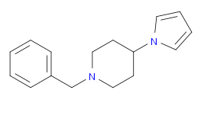 C(N1CCC(CC1)N2C=CC=C2)C=3C=CC=CC3  Z2856434898
64 | 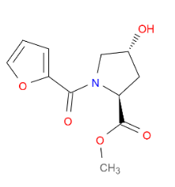 COC(=O)[C@@H]1C[C@@H](O)CN1C(=O)C2=CC=CO2  Z1614545742
68 | 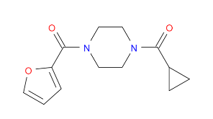 O=C(C1CC1)N2CCN(CC2)C(=O)C3=CC=CO3  Z32327641
69 | 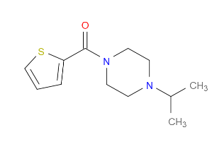 CC(C)N1CCN(CC1)C(=O)C2=CC=CS2  Z2856434826
71 | 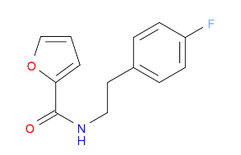 FC=1C=CC(CCNC(=O)C2=CC=CO2)=CC1  Z26769872
90 | 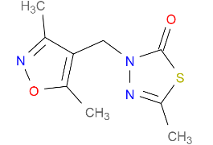  CC1=NN(CC=2C(C)=NOC2C)C(=O)S1  Z1899842917
94 | 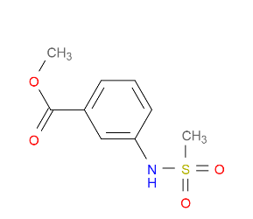 COC(=O)C=1C=CC=C(NS(=O)(=O)C)C1  Z24758179
109 | 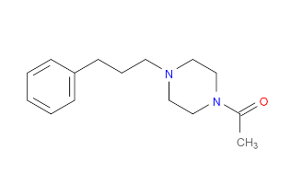 CC(=O)N1CCN(CCCC=2C=CC=CC2)CC1  Z2856434884
117 | 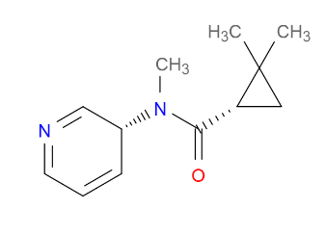 CN(C(=O)[C@H]1CC1(C)C)C=2C=CC=NC2  Z1506050651
221 | 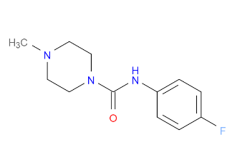 CN1CCN(CC1)C(=O)NC=2C=CC(F)=CC2  Z2856434944
296 | 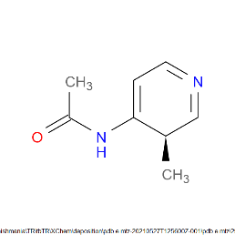  CC(=O)NC=1C=CN=CC1C  Z1148747945
371 | 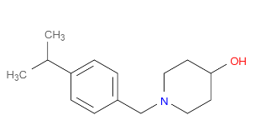 CC(C)C=1C=CC(CN2CCC(O)CC2)=CC1  Z2856434874

